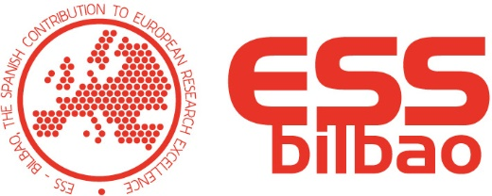
ANNEX IV. APPLICATION FORM

PERSONAL DETAILS
FAMILY NAME(S): .................................................................................................................................................................

FIRST NAME(S): .............................................................. ID/PASSPORT NO: …............................................ GENDER: ….............................

STREET: ................................................................................... NUMBER: .............. FLAT: .................... POST CODE: ..........................

TELEPHONE: ..................................TOWN: ............................... PROVINCE: ................................ COUNTRY: ......................................
DATE OF BIRTH: ................................. PLACE OF BIRTH: ........... .........................COUNTRY OF BIRTH: ...............
.............. NATIONALITY: ............................................................................. E-MAIL: .................................................................................

SELECTION PROCESS
DATE OF ANNOUNCEMENT: 18 November 2020 REQUIRED TECHNICAL PROFILE: RESEARCHER NEUTRON INSTRUMENTATION

POSITION CODE: Ref. 2002

CÓDIGO PLAZA SOLICITADA: REF. 19………
ESS BILBAO CONSORTIUM
MINISTRY: ENTITY:
ADDRESS:
MINISTRY FOR SCIENCE, INNOVATION AND UNIVERSITIES
Parque Tecnológico de Bizkaia, C/ Laida Bidea, 207 B semisótano 2 Derio 48160

MINIMUM TRAINING REQUIREMENTS (Must be current and demonstrable at closing date for applications)
Ph D in Science (Physics or Chemistry) / MS Physics or Chemistry / MS Electronics Engineering or similar

SKILLS

PROFESSIONAL SKILLS:
 | EXPERIENCE IN POSITIONS OF LOWER RESPONSIBILITY WITH SIMILAR TASKS AND FUNCTIONS |  |  | EXPERIENCE IN POSITIONS OF SAME OR HIGHER RESPONSIBILITY WITH SIMILAR TASKS AND FUNCTIONS
 | JOB TITLE | PUBLIC ENTITY OR COMPANY | PERIOD WORKED (YEARS, MONTHS, DAYS)
TRAINING MERITS:
 | OTHER QUALIFICATIONS AND SPECIALISATIONS

MASTERS
LANGUAGES

Signed

In ........................................................, on the .............. day of ........................................., 20 ...................

Under the specifications of General EU Ruling 2016/679 on Personal Data Protection, we require your consent to allow the ESS Bilbao Consortium to use the personal data that you provide as part of this Call for Applications with the sole aim of processing your application. The data requested is only that which is strictly necessary to correctly identify the person making the application and follow the necessary procedures for management and distribution of the information processed as part of this Selection Process. It will be deleted once the process has finished. As stated in this Ruling, you may at any time exercise your rights to access, rectify, suppress, limit or challenge the treatment and transmission of your personal data either by e-mail (rrhh@essbilbao.org) or by sending a letter (Parque Tecnológico de Bizkaia, C/ Laida Bidea, 207 B semisótano 2 Derio 48160, Spain), accompanied by a document to validate your identity (Passport/Identity Card). Through these channels you may withdraw your consent at any time without affecting in any way the treatment that the data has already received. You are fully entitled at all times to make a complaint regarding any aspect of this area to the Spanish Data Protection Agency.

